**Air Quality Analysis Tableau**

Summary:

Air pollution remains the greatest environmental threat to human health. According to the World Health Organization (WHO), 99% of the global population lives in areas that do not meet recommended air quality guideline levels. Air pollution is the second leading global risk factor for death, and the second leading risk factor for deaths among children under five, following malnutrition, due to its significant impact on respiratory and developmental health. In 2021 alone, 8.1 million total deaths were attributable to air pollution, with 58% of those deaths caused by ambient PM2.5 air pollution.

The United Nations has declared access to healthy air is a universal human right. Exposure to PM2.5 contributes to and exacerbates various health conditions, including asthma, cancer, stroke, and lung diseases. In addition, exposure to elevated levels of fine particles during pregnancy and early childhood are associated with congenital heart defects, eczema and allergic disease, cognitive impairments and delays, neurodevelopmental disorders, and mental health disorders.

It is our shared responsibility to safeguard the health and well-being of the world’s children, who will one day become the leaders of tomorrow. By equipping them with the knowledge and resources they need, we empower them to tackle the global challenges of the future. Air pollutants, including carbon monoxide (CO), sulfur dioxide (SO2), particulate matters (PM10, PM2.5), nitrogen dioxide (NO2), and ozone (O3). When compared to these pollutants, particulate matter (also called particle pollution): the term for a mixture of solid particles and liquid droplets found in the air. Numerous scientific studies have linked particle pollution exposure to a variety of problems, including premature death in people with heart or lung disease, nonfatal heart attacks, irregular heartbeat, aggravated asthma, decreased lung function, increased respiratory symptoms, such as irritation of the airways, coughing or difficulty breathing.

Objectives:

1. To identify the country and city which is most affected by all pollutants.
2. A detailed study of air pollutants: CO, NO2, O3 and SO2, Pm 2.5 and Pm 10.
3. To identify trends and patterns in weather and pollutants.
4. To find out how weather conditions affect the pollution level based on various pollutants.
5. To perform correlation analysis between pollutants and weather conditions.
6. To understand the air quality trends: monthly and weekly.

Dataset:

The dataset is composed of the following columns:

The Global Air Quality Data dataset provides an extensive compilation of air quality measurements from various prominent cities worldwide. This dataset includes crucial environmental indicators such as particulate matter (PM2.5 and PM10), nitrogen dioxide (NO2), sulfur dioxide (SO2), carbon monoxide (CO), and ozone (O3), along with meteorological data like temperature, humidity, and wind speed. With 10,000 records, this dataset will help to analyze air quality trends, understand the impact of pollution on health, and develop strategies for environmental improvement.

City: The name of the city where the air quality measurement was taken.

Country: The country in which the city is located.

Date: The date when the measurement was recorded.

PM2.5: The concentration of fine particulate matter with a diameter of less than 2.5 micrometers (µg/m³).

PM10: The concentration of particulate matter with a diameter of less than 10 micrometers (µg/m³).

NO2: The concentration of nitrogen dioxide (µg/m³).

SO2: The concentration of sulfur dioxide (µg/m³).

CO: The concentration of carbon monoxide (mg/m³).

O3: The concentration of ozone (µg/m³).

Temperature: The temperature at the time of measurement (°C).

Humidity: The humidity level at the time of measurement (%).

Wind Speed: The wind speed at the time of measurement (m/s).

Results:

1. Country-wise Analysis:
2. Weather conditions: The average temperature, wind speed and humidity, Pm 2.5 and Pm 10 for each country is shown in figure. The parameters used for assessing the weather conditions in countries are: temperature, wind speed and humidity.

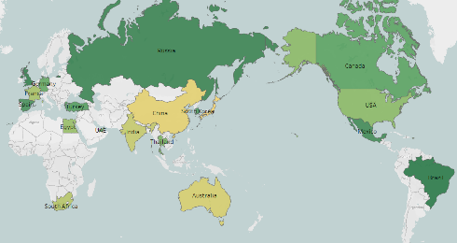

The average temperature for each country varies from 14°C to 16.2°C where Rio De Janeiro in Brazil has maximum value of average temperature and Tokyo in Japan has minimum average temperature. The average wind speed in each country varies from 9.9m/s in Bangkok (Thailand) to 10.5m/s in Madrid (Spain). The variation in humidity in each country ranges from 53.7% in USA to 56.5% in Bangkok (Thailand).

The variation in different pollutants is shown below:

1. Pm2.5/10: The average concentration of Pm2.5 levels ranges from 74.7 µg/m³ in Paris (France) to 80 µg/m³ in Dubai (UAE). Similarly, the concentration of average Pm10 levels ranges from 102.9µg/m³ in Cairo (Egypt) to 106 µg/m³ in Moscow (Russia).
2. CO: The average concentration of carbon monoxide levels ranges from 4.8 mg/m³ in Madrid (Spain) to 5.26 mg/m³ in Bangkok (Thailand).
3. NO2: The average concentration of nitrogen dioxide levels ranges from 50.1 µg/m³ in Cairo (Egypt) to 53.8 µg/m³ in Paris (France).
4. O3: The average concentration of ozone levels ranges from 101 µg/m³ in Bangkok (Thailand) to 111 µg/m³ in Toronto (Canada).
5. SO2: The average concentration of sulphur dioxide level ranges from 24.5 µg/m³ in Berlin (China) to 28 µg/m³ in Tokyo (Japan).
6. The combined effect of all pollutants was measured by adding the values of all pollutants CO, NO2, O3, SO2, Pm 2.5 and Pm 10. The average concentration of all pollutants was highest in Tokyo-Japan with value 378.14 and lowest in Bangkok-Thailand with value 364.75.

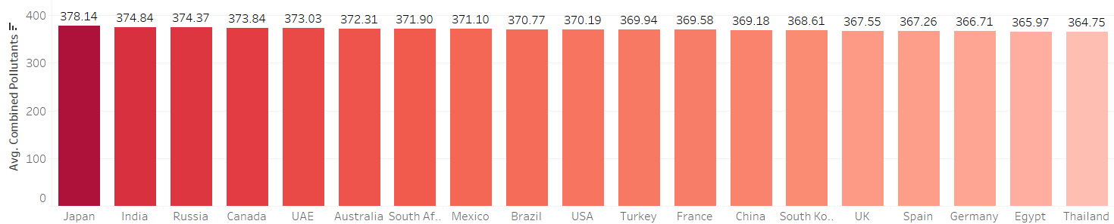

Trend Analysis:

Seasonal Trend: The monthly and daily variation in pollution levels is shown in figure below:

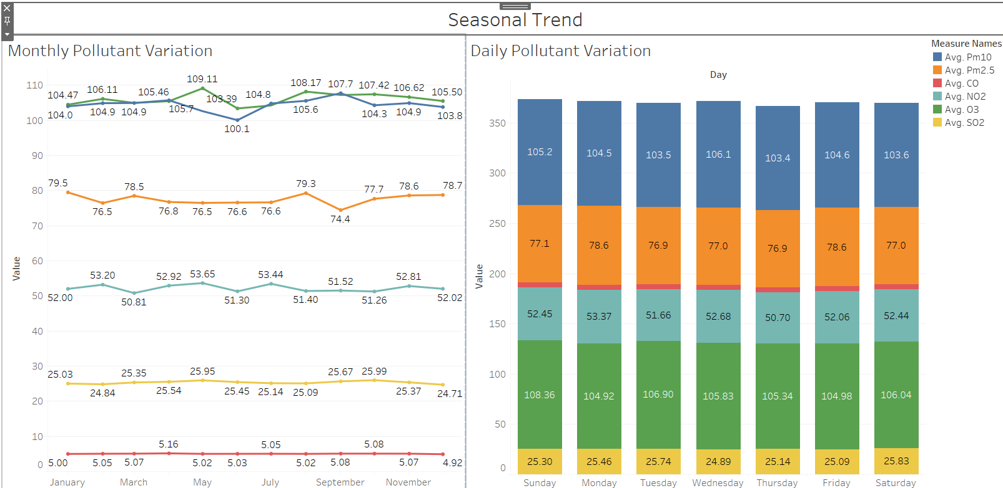

The line chart of Pm 2.5 levels has peak in **August** indicating the highest value of 79.3 µg/m³ and lowest in September with a value of 74.4 µg/m³.

The peak and troughs of Pm 10 levels are in the months of **September** and June with values 107.7 µg/m³ and 101.1 µg/m³ respectively. It indicates that September and June has maximum and lowest Pm 10 levels concentration.

The line chart of carbon monoxide is flat with very little or no monthly variation in CO levels. However, April has comparatively higher CO levels of 5.16 mg/m³ and December has lower CO levels of 4.92 mg/m³.

The line chart of nitrogen dioxide has three peaks in the months of **February, May and July** with an average concentration of 53.2, 53.6 and 53.4 µg/m³ respectively. However, the minimum average concentration of NO2 is in the month of March with value of 50.1 µg/m³ respectively.

The graph of sulphur dioxide has little variation throughout the year. It has peak concentration in the months of **May and October** with values 25.9 µg/m³. The lowest average concentration is in the months of February and December with value 24.7 µg/m³.

The line chart of ozone shows the average concentration of the pollutant. It was observed that the peak value is in the month of **May** with value 109.1 µg/m³. Similarly, the lowest value is in the month of June with value 103.4 µg/m³.

Weekly Trend:

The average concentration of Pm 2.5 pollutant is highest on **Monday and Friday** with value 78.6 µg/m³ and the lowest average concentration is on Tuesday and Thursday with values 76.9 µg/m³.

The average concentration of Pm 10 is highest on **Wednesday** and lowest on Tuesday, Thursday and Saturday with values of 106.1 µg/m³ and 103.5 µg/m³ respectively.

The avg. concentration of carbon monoxide is highest on **Tuesday** with value 5.13 mg/m³ and lowest on Sunday with value 4.9 mg/m³. Similarly, the average concentration of nitrogen dioxide is peak on **Monday** with value 53.37 mg/m³ and lowest on Thursday with value 50.7 mg/m³. The avg. concentration of Ozone is maximum on Sunday 108.4 mg/m³ and minimum on Monday and Friday with value 104.9 mg/m³ respectively.

There is very little daily variation in average concentration of Sulphur dioxide. The level is high on **Saturday** at value 25.8 µg/m³ and low on Wednesday with value 24.8 µg/m³.

Weather Analysis:

Temperature: The minimum temperature is -10 °C and maximum temperature is 40 °C. Average temperature is 14.9°C. 50% of places have temperature below 14.76 °C whereas 75% of places have temperature below 27.4 °C.

There are no outliers indicating that there are no places considered in dataset which have extremely high or low temperature.

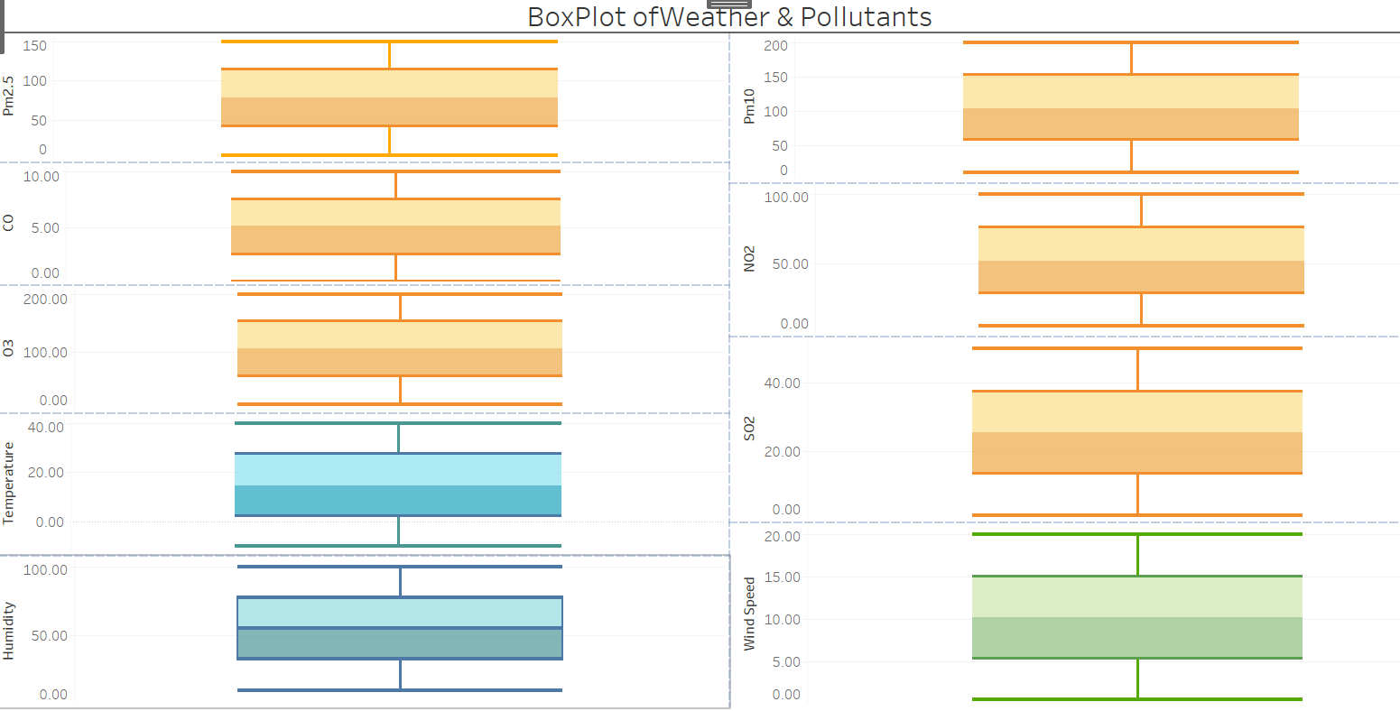

Wind speed: The data contains places with minimum wind speed of 0.5 m/s to places with highest wind speed of 20 m/s. 50% of places have wind speed less than 10.3 m/s and 50% of places have wind speed of more than 10.3 m/s. 75% of places have wind speed of less than 15.1m/s. As no outliers in data so dataset does not contain places with extremely high or low wind speeds.

Humidity: The humidity lies between 10% and 99.99%. 50% of places have humidity of less than 55.1% and 50% of places in data have humidity more than 55.1%. 75% of places have humidity of less than 77.5%.

Pm2.5: The concentration of Pm 2.5 particles range from 5 to 150 µg/m³. The middle 50% of places have Pm2.5 concentration between 41.2 and 113.4 µg/m³. 50% of places have pm 2.5 concentration below 77.7 µg/m³ and 75% of places have Pm 2.5 levels below 113.4 µg/m³.

Pm 10: The concentration of Pm 10 particles range from 10 to 200 µg/m³. The middle 50% of places have Pm10 concentration between 57.1 and 152.3 µg/m³. 50% of places have pm 10 concentration below 103.7 µg/m³ and 75% of places have Pm 10 levels below 152.3 µg/m³.

The average and median values are nearly equal in boxplots of all pollutants and weather parameters indicating that they follow a normal distribution. This concludes that it is a symmetric distribution with most values are clustered near the mean fewer values are farther away. The average values of temperature, wind speed, humidity, Pm 2.5, Pm 10, CO, NO2, O3 and SO2 are: 14.9°C, 10.23m/s, 55.1%, 77.4 µg/m³, 104.4 µg/m³, 5.1 mg/m³, 52.2 µg/m³, 106 µg/m³ and 25.34 µg/m³.

Correlation Analysis: The R-square value for all parameters is approximately 0 indicating that there is no relationship between dependent and independent variables. However, the slope of graphs between temperature and Pm2.5 and Pm 10 is negative indicating as temperature increases, the pollutant level decreases. Similarly, the graph between wind speed vs Pm 2.5 and humidity vs Pm 2.5, slope is negative indicating that as wind speed and humidity increases, the Pm 2.5 concentration decreases. The slope of trend line in wind speed vs Pm 10 and humidity vs Pm 10 is positive indicating that as wind speed and humidity increases, Pm 10 levels increase.

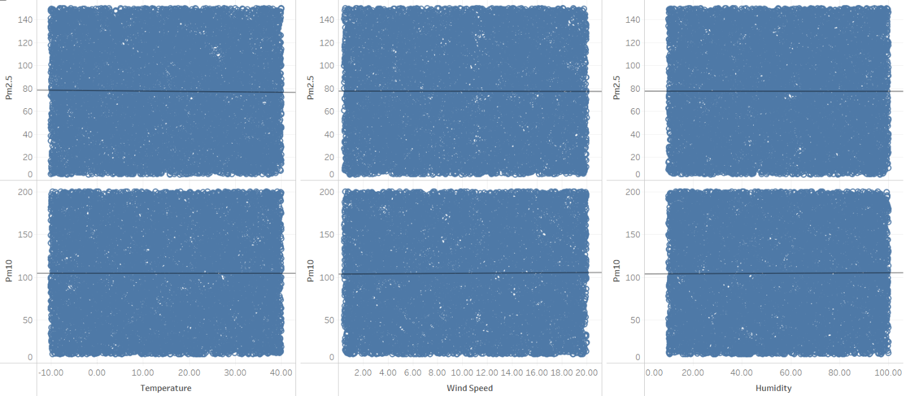

Places with highest concentration of each pollutant:

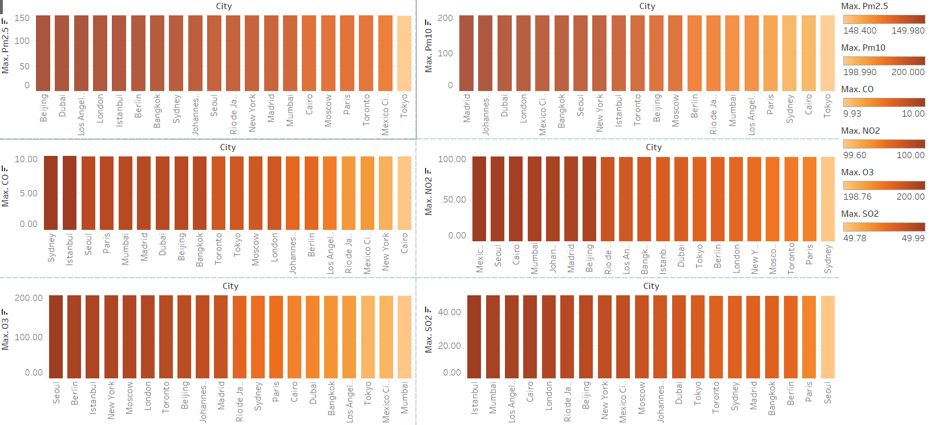The analysis of pollutants is based on following parameters: Pm 2.5, Pm 10, CO, NO2, O3 and SO2. It was observed that Beijing-China has highest concentration (149.98 µg/m³) of Pm2.5 and Madrid in Spain has highest concentration(200 µg/m³) of Pm 10 particulate matter. The cities Mexico, Seoul, Cairo, Mumbai, Johannesburg, Madrid and Beijing have maximum NO2 concentration of 100 µg/m³ where Seoul in South Korea has highest concentration of O3 of 200 µg/m³. The highest concentration of SO2 is in 9 cities: Istanbul, Mumbai, Los Angeles, Cairo, London, Rio de Janeiro, Beijing, New York and Mexico, each with a value of 50 µg/m³ of SO2.

Conclusion: The data has been collected from following countries: Australia, Brazil, Canada, China, Egypt, France, Germany, India, Japan, Mexico, Russia, South Africa, South Korea, Spain, Thailand, Turkey, UAE, UK and USA. The data is collected throughout the year 2023. The average weather condition in these countries based on temperature, wind speed, humidity are: 14.9°C, 10.23m/s, 55.1%. The temperature variation is from -10°C to 40°C.

Brazil is warmer country and Japan is colder as compared to other countries. Madrid in Spain has higher average wind speed and Bangkok in Thailand has high humidity as compared to other places. The highest concentration of average Pm 2.5 and Pm 10 pollutants in 2023, is in Dubai (UAE) and Moscow (Russia). The countries with lower Pm 2.5 and Pm 10 pollutants are: Paris in France and Cairo in Egypt.

The average concentration of pollutants Pm 2.5, Pm 10, CO, NO2, O3 and SO2 are: 77.4 µg/m³, 104.4 µg/m³, 5.1 mg/m³, 52.2 µg/m³, 106 µg/m³ and 25.34 µg/m³.

It was observed that Beijing-China has highest concentration of Pm2.5 and Madrid in Spain has highest concentration of Pm 10 particulate matter. The cities Mexico, Seoul, Cairo, Mumbai, Johannesburg, Madrid and Beijing have maximum NO2 concentration where Seoul in South Korea has highest concentration of O3 of 200 µg/m³. The highest concentration of SO2 is in 9 cities: Istanbul, Mumbai, Los Angeles, Cairo, London, Rio de Janeiro, Beijing, New York and Mexico. Finally, Beijing in China had peak concentration of all pollutants during the year 2023 indicating the most polluted place in the world.

There is little monthly and daily variation in CO and SO2. Based on Pm 2.5 and NO2 levels, Monday has highest concentration of these pollutants. In the months of August and September, the concentration of average Pm 2.5 and Pm 10 levels are highest. Also, May has highest levels of NO2, SO2 and Ozone.

There is no correlation existing between weather conditions and Pm 2.5, Pm 10 pollutant levels during the year 2023.

**References**

https://www.iqair.com/in-en/world-air-quality-report?srsltid=AfmBOorB8GjRfjyRQ7JlfDrGmxTZshdMPw1uG7v22E_vtT2qrGic3emV